Facebook Ads   
Real Estate Ads

short line

## **Ever wonder how some ads get more clicks? Facebook Real Estate copy for ads**

Are you a real estate agent looking to maximize the potential of Facebook advertising?   
Wonder how your competitor has lots of foot traffic in their open houses?   
It can be difficult for your ads to stand out from the crowd - this market is highly competitive.   
The secret sauce is in your ad copy and image - you need to craft compelling content that directly speaks to prospects' home buyers or sellers. To help you make the most of this platform, we've broken down the key components of great ad copy and provided 10 different ways to refine and optimize your promotions.   
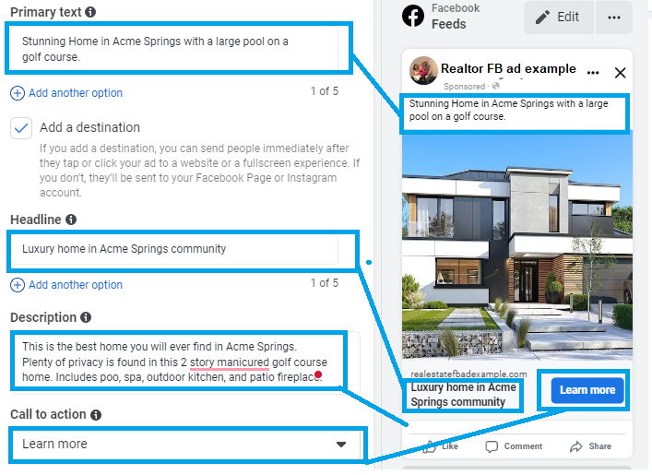

Here are all the opportunities to create attractive and complete copy for your user to want to click on your ad.

**Primary Text - Ad Copy:**The reader will see the compelling photo first. Then scan the text above to understand the context. The text mentions the most compelling features; golf course, large pool, outdoor kitchen etc. They could be accompanied with emoji symbols to refer to these features. But too many and it will look spammy. Facebook cuts the ‘primary text’ off after the 2nd sentence. Have the best features mentioned or keywords first.

**Headline - Ad Copy:**  
Be precise and brief about the home, the features, or location - whichever is the most compelling. This has a word limitation.

**Description - Ad Copy:**   
This text is partially hidden. Refer to this area by adding additional keywords of the home’s feature and location. Many times users will not see this area.

**Call To Action - Selection:**  
Most commonly used selection is ‘learn more’ - this brings the user to the website. More clicks on the website - better for ranking in Google Search Engine results.

**Character limits:** Adhere to character limits:

* Text: 125 characters
* Headline: 25 characters
* Link Description: 30 characters
* Display URL: 30 characters

## **Facebook Real Estate Tone**

**To make a Facebook ad successful, you need the right tone - by being enthusiastic and compelling.**

When crafting an ad for a property, tune in on your intended buyer and write with them in mind. By employing a friendly tone and style, and following these nine tips, you’ll create captivating copy that prompts clicks and drives interest in your offering. Inject enthusiasm into your words and make sure the information you supply is accurate and actionable. Design an engaging headline, leverage powerful visuals, make use of keywords and emotive language, and highlight features that benefit potential buyers. Your composition should be detailed, and leave a lingering imprint on the reader’s mind. With the right blend of creativity and calculated precision, you can harness the power of Facebook ads to launch successful ad campaigns that will truly entice.

**Start Your Ad Campaign With a Strategy**

**Facebook Ads can help you capture leads (seller and buyer leads), increase traffic for open houses, and maintain your brand.**

When it comes to Facebook advertising, blindly spending $$$ on FB ad campaigns without a clear goal in mind is a recipe for a disaster and a waste of money! That’s why Facebook makes sure that the very first step to creating an ad is selecting an objective. From building brand awareness to building clicks to site to generating leads, there’s something suitable for every situation, so take some time to truly consider what you’re trying to achieve. Once you have your objective, you can then look into different types of ads and target audiences—both essential for achieving more clicks to your site or more clients. While these decisions require careful consideration, always remember to keep your overall aim in check!

## **Why Create Ads on Facebook?**

**Facebook ads reaches a large audience**A major benefit of Facebook advertising is its ability to reach your exact audience.

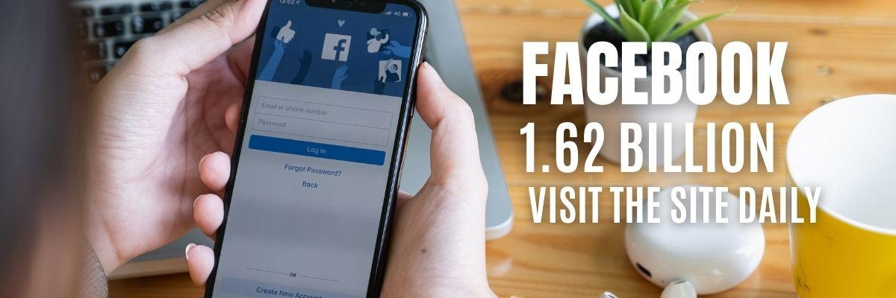One of the reasons Facebook ads are so compelling is that they offer a variety of formats and placements to help companies engage users. There’s no one-size-fits-all approach because different people respond to different tactics. So, before you launch a Facebook ad, make sure you fully understand the ‘Housing’ requirements for FB ad format. See the document ‘Creative Content for Ads’.

**FB Ads reach your ideal customer base and expand your brand’s visibility.**  
  
Facebook Ads are an effective tool for attracting new customers who may otherwise be unaware of your products or services. With Facebook Ads, you can narrow down your audience and target specific demographics based on location, age, interests, behaviors, and more (not including gender and income). You have the power to precisely tune in on potential customers who fit your criteria and unleash powerful campaigns that will capture their attention. By crafting compelling copy, developing captivating visuals, and deploying precise targeting strategies, you can deliver ads that engage viewers and inspire them to take action.

## **10 Tips to Create Perfect Facebook Content**

## **1. Appeal to the audiences’ desires** If you want to captivate the attention of a potential buyer, it's best to avoid generic ad copy and pinpoint the desire of the buyer/seller. By understanding what your customers want from life, you can deliver a more personalized message tailored specifically to them. Take luxury buyers, for example. Adding phrases such as ‘home theater’, ‘outdoor kitchen’ or ‘large pool’ to your ad copy shows that you acknowledge and share their love of “luxury” items. The other important aspect of a successful Facebook ad - is imagery. Hire a photographer if you need. Post several photos of the house - inside and out - plus the floor plans. Your ads will stand out from the rest and speak directly to their desires. So, skip the dull, universal phrasing and take the time to really get to know your audience.

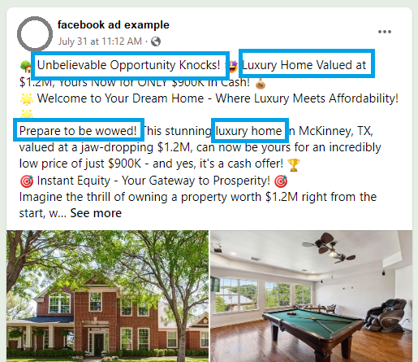

## 

**2. FOMO**

Best trick is to use FOMO: the 'fear of missing out' in your Facebook ad copy. By stating the sense of urgency and anxiety in potential customers, you can drive them to take action and purchase the home you’ve listed before it's gone! Crafting language that encourages swift decision-making is key. With phrases like "going to sell FAST", “Prepared to be wowed!” and "before anyone else sees it",

you can make even the most **indecisive customers** eager to take part. Get creative and make sure your house is the only one like it on the market.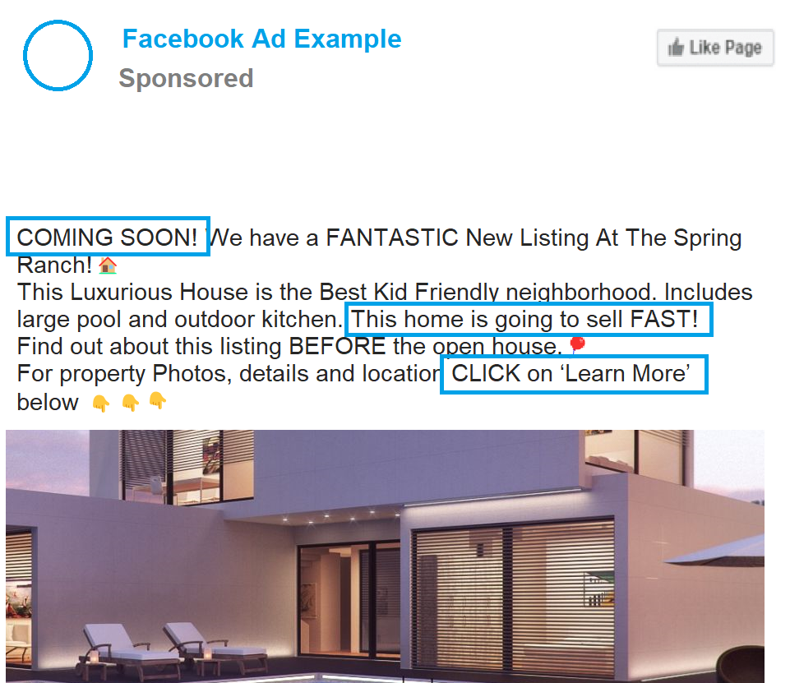

While FOMO can be very effective, you shouldn’t overdo it. If you use too much of this heightened language, the ad copy will start to feel insincere to viewers. Use no more than three FOMO phrases to motivate buyers to click without overwhelming them.

**3. Agent Contact Info**

With your phone number prominently featured in the ad, potential leads can call you instantly — no clicking required! Ideally Mention: phone number and have the call to action - be the ‘Learn More’ button to your site with more info on this home. Leads can multiply quickly. Even if every lead doesn’t immediately call you, having your details in the ad and the ‘learn more’ opens your website up the chance for more instant connections and swift conversions. Make it easy for customers to reach out to you for questions on a home or future listings!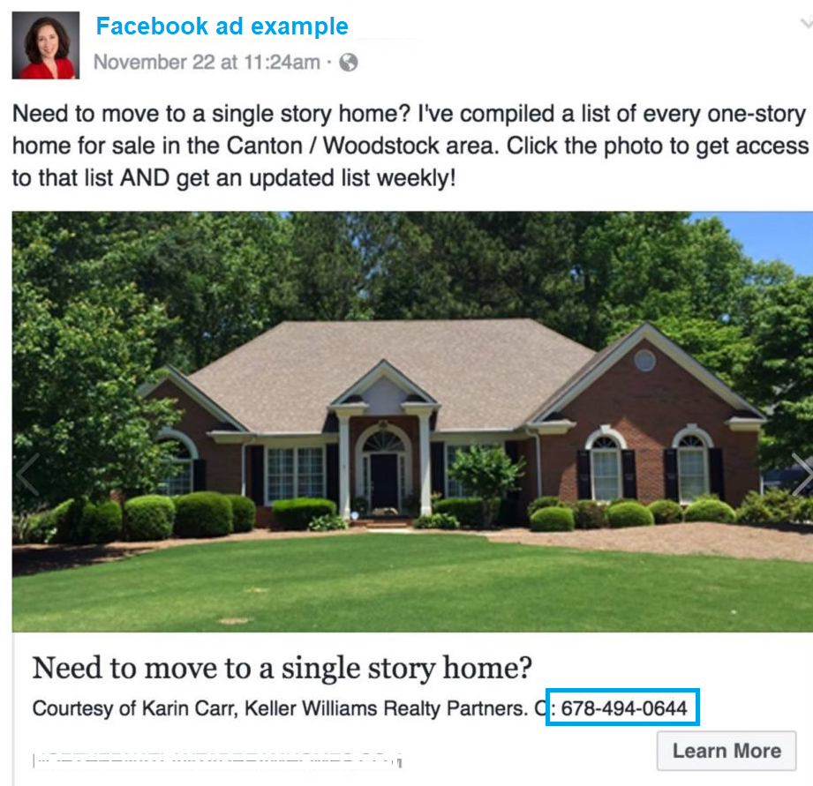

**4. The Power of Emojis**

Express yourself in the most dynamic way with emojis! With a few simple strokes, you can instantly enliven your message and captivate the attention of newsfeed browsers. Unsure how to navigate this virtual pictorial language? Simply consult Emojipedia for every single emoji under the sun! From 💃🏻 dancing queens to [👽](https://emojipedia.org/alien/) wide-eyed aliens, your communication will be eye-catching with the use of variety of emoji icons. 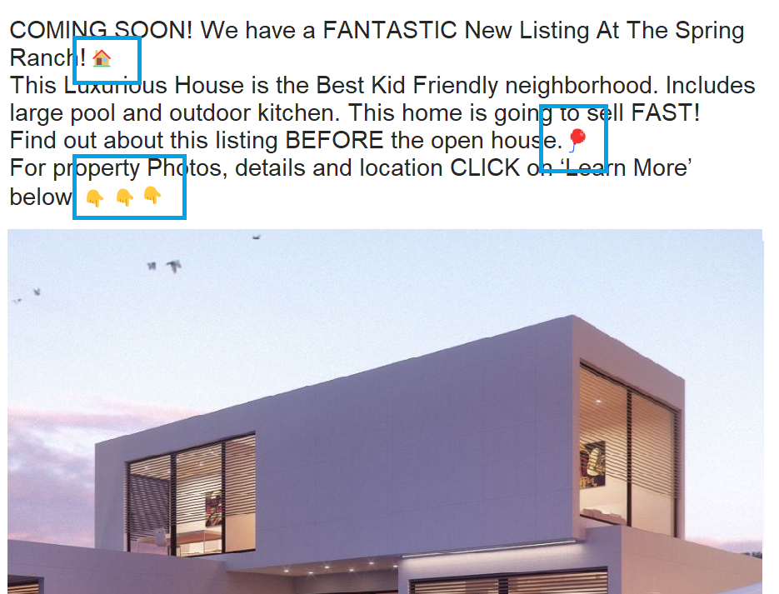

### **5. Add links in your ad for more licks**

All website links lead to more traffic to your website. More traffic to your website = better ranking in Google for search results for your website. Take advantage of link posts on Facebook! Although the interactive preview may draw your audience in, don't forget to leave that link for them to click. Sure, it may not look great in the post, but those few extra clicks can really make a difference! Keep it friendly and conversational; you can still encourage visits without intimidating or alienating your followers.

### **4. Retarget Clicks and Views**

### **Ads Allow You to Remarket to People Who Have Already Interacted With You** The first time people see your business on Facebook or your website, they click on it because they have some interest but then move on. Those people that clicked on your site/fb page - you can target future ads too. In the future, if they see your ad again, it gives you a higher chance of converting those people. Running ads to those that have already visited your site is your best ROI advertising you can buy. Those viewers would be considered ‘warm’ leads - so to speak. This is all done with a Fb pixel on your website.

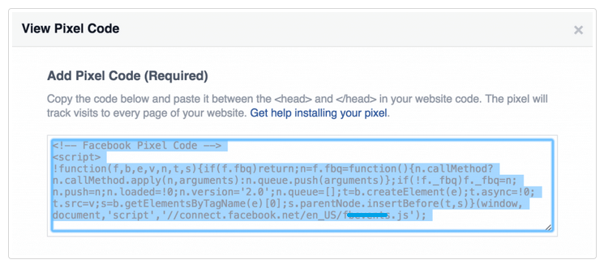

**How can you retarget visits to your site?**

Facebook Pixel is a simple piece of code you can add to your website, specifically designed to monitor user behavior and survey how people are engaging with your website. Track pageviews, time on site, scroll depth, and more—all to gain an understanding of what works best for your business. You can even use the Facebook Pixel to create amazing retargeting campaigns, targeting the perfect audience with precisely tailored ads. With just a few clicks, unlock the potential of data-driven marketing and leverage this powerful tool to achieve remarkable results!

**7. Promote neighborhood and local attractions in the ad**

Facebook ads to sell homes - It's all about location, location, location! Your dream property should include not just the right features and amenities, but also those special attractions nearby that will make life even more enjoyable. Mentioning upgrades and attractions for kids and adults like a golf course nearby or a pool in the backyard! Being transparent can help you reach an audience who are likely interested in these landmark attractions. 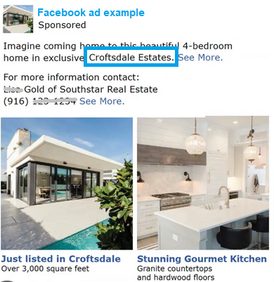

### **8. Create a neighborhood guide**

If you specialize in a certain city or have several listings in the same neighborhood, create a blog post or page on your website about that area. Include facts buyers would find interesting, such as the population, average age ranges, any great restaurants or attractions nearby, how walkable it is, the top notch schools and more. Take several communities and promote them in Videos. Make sure they have these videos uploaded to YouTube- for better search value in Google. Sure do TikTok videos. Google does not rank TikTok videos. Our goal is to get clicks on the ad and clicks on the website - for better search ranking in Google and better ROI.

**9. People want to work with the ‘Best”**

Did you hit the top 1% of sales this year? Have you won any other awards, like ‘best realtor’ from your city or community organization? Did the listing sell in record time?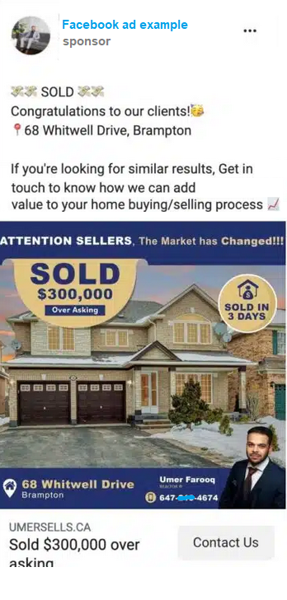

Use it to (modestly) show off how great you are. Of course, don’t brag too much and risk turning people away. Use your good judgment to figure out where that line should be. People want to work with the ones that have the most experience and can navigate home buying for you easily and efficiently.

If you want to stand out from the crowd, it's time to be bold and let the audience know that - you are the best. Make yourself known with ads that showcase your achievements. Plaster your result. Since people will want the results you have delivered. Show your personality and watch the results pour in.

**10. Use Videos for your ad**

If pictures speak a thousand words, then what can a video or a virtual tour do? For real estate agents, it can do a lot. Facebook video ads allow you to guide a potential buyer through your listing in the most optimal way, without having to be in person.  
For example, if a room has two exit points, one of which leads to an unappealing part of the house, the virtual tour can guide the potential buyer through the house in the most appealing pathway.  
If you don’t have a full-blown virtual tour to promote your real estate Facebook ad, you can always use Facebook’s slideshow feature - carousel - like running slides of images on an ad.  
**Facebook video time limitation**: Video Duration: 1 second to 241 minutes

**Frequently asked questions**

**Are Facebook ads effective for realtors?**

YES! Yes! yes! If you're in the real estate business, then rejoice – Facebook advertising is your ideal companion. From breathtaking visuals to powerful referrals, these ads are tailor-made for the realty industry – helping you place Facebook Ads with brand awareness and expand your network of contacts.

**How much do Facebook ads cost?**

Facebook advertising is here to revolutionize your business and take it to the next level. Facebook ads can have visuals that draw in potential clients while leveraging referrals to solidify your reputation. Plus, you have total control over how much money you want to invest—whether it’s $5 per week or $5,000. And don't worry, Facebook has plenty of tools to help you manage the cost of getting results - so that your budget isn't stretched too thin.

**What are the 4 different Facebook ad types?**

**Image Ads:** There are various Facebook ads placements that could require different graphic sizes. If you want to place ads on Facebook and Instagram - they will require different ad sizes. Best practice is creating images for Facebook ads with an aspect ratio of 1080 x 1080 pixels. Of course, make sure the file size is not too large.  
**Recommended Facebook ad aspect ratio**: 1.91:1 to 1:1. In general, ratios from 1.91:1 to 4:5 are supported. However, if you include a link, launch an Offer ad, or use stock images, you'll be limited to a ratio of 1.91:1.

**Video ads:** The numbers don't lie–84%* Video marketers are using Facebook as one of their main video marketing channels. Marketers can create Facebook ads from scratch or reuse a posted video and convert it into an ad. Many companies have found that video advertising gets more engagement, clicks, and increased conversions.  
**Recommended Facebook ad aspect ratio**: File Type: MP4, Recommended Ratio: 9:16, Resolution: At least 500 x 800 pixels

**Carousel ads:** The power of the carousel ad allows you to captivate the audience by using several images to showcase a variety of content all at once. From three to five images and headlines, your creative options are limitless. Carousels give you more freedom to tell a story, making them an ideal choice for campaigns that demand more than a single video or image. Crafting such multi-faceted ads may take up more of your time.

**Collection ads:** A collection ad in Facebook News Feed includes a cover image or video followed by 3 product images. These are like products for a store. When someone taps on a collection ad, they see an **Instant Experience**—a full-screen landing page that drives engagement. When you create your Instant Experience, you can use the Storefront, Lookbook or Customer Acquisition templates, or build a custom Instant Experience. (new)

# **Successful FB ads**

short dash  
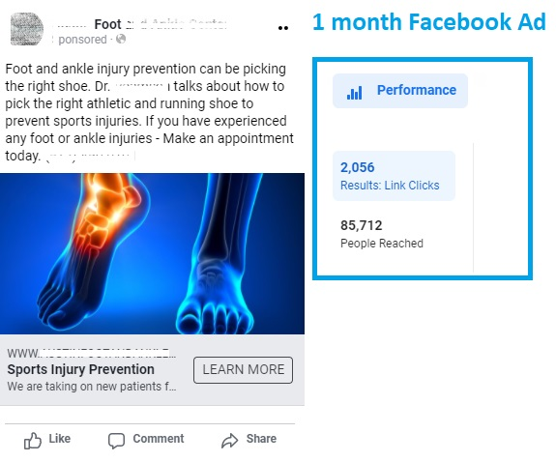

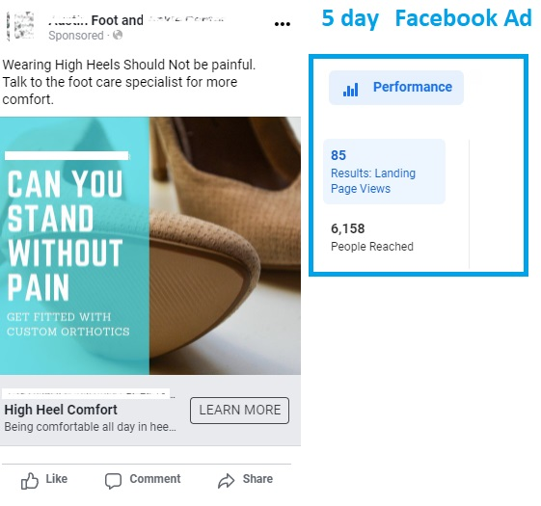

* <https://www.yansmedia.com/blog/facebook-video-statistics>

**FB ad Partner**

**We can help you outsmart your competitors by partnering with you to create successful Facebook ad Campaigns.**

## **Increased Sales/Leads**

Using Facebook Ads to reach your target audience can be intimidating. The Ads Manager juggles a myriad of settings, offers varied targeting options, supports diverse advertising strategies, and integrates with other tools depending on the direction of your business. Lucid Crew can help you tap into an immense pool of potential customers and maximize your success. We have a plan in place so you can focus on your business while we get you more leads.

**Facebook Partner Free: $500 a month**

**Includes:**

* **One time Facebook Ad Setup**
* **Create compelling Fb ad Campaigns (staying within your budget)**

**Lucid Crew**

**512.791.4216**